**Q4-ANSIBLE-DOCUMENT**

Organize the project



Nano Host.ini file (inventory)

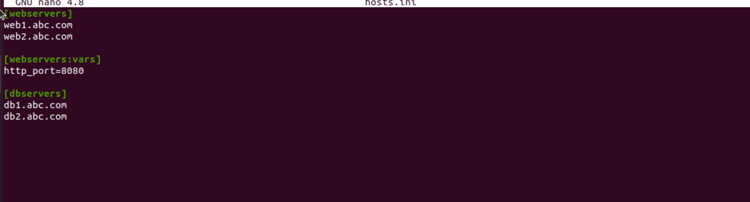

Run the below command to verify the structure is correct

